G. Bryan Slater Secretary of Labor

*COMMONWEALTH of VIRGINIA*

*Office of the Governor*

March 20, 2025



Andrea Driffill

Email: [andrea@virginiaconsumer.com](mailto:andrea@virginiaconsumer.com) Dear Ms. Driffill:

Thank you for your correspondence of dated March 3, 2025, regarding the procession of

your complaint with DPOR (Case file number: 2023-00756). Upon reviewing our prior communications on this topic, I noticed that some of the issues you raised in your recent email are new, while others are either updates or restatements of concerns previously addressed in our letter to you dated May 9, 2024, from Kishore Thota, the former Agency Director.

As you are aware, following your email of April 9, 2024, I asked Mr. Thota and his senior team, including both an appointed official and senior classified employee with substantial regulatory enforcement experience, to thoroughly review your case file and provide you with the results of their assessment. In his May 9, 2024, letter, Mr. Thota outlined their findings and detailed DPOR's actions in response to each of the 16 allegations you raised. In light of your most recent communication, I have assigned another appointed official, with extensive experience in both state and federal government, to conduct an additional review of the case file and the actions taken by our staff.

This official has reported his findings to me and the Agency Director, Brian Wolford.

After our discussions and careful consideration, we have concluded that your case was thoroughly investigated and that the results borne from the investigative and adjudicative process were appropriate and supported by the evidence developed during the case. While we

Patrick Henry Building • 1111 East Broad Street • Richmond, Virginia 23219 • (804) 225-2849 • TTY (800) 828-1120

realize that you have a differing opinion, we hope the following information, along with the information provided to you previously, is helpful.

Regarding unlicensed contracting, you noted in your recent email that DPOR only referred a single matter to the Office of the Attorney General out of "5,000 complaints" and suggested there is "no evidence to suggest that law enforcement would be interested in investigating, because that step is avoided." The Virginia Code provides that engaging in unlicensed contracting is a misdemeanor criminal offense (that can be elevated to a felony upon more than three convictions), but it is local Commonwealth's Attorneys, and not the Office of the Attorney General, that has the jurisdiction to prosecute such misdemeanors. In this regard, DPOR routinely works with local prosecutors across the state to prosecute unlicensed professional conduct. Over the last biennium of FY2023 and FY2024, DPOR completed over 600 investigations of unlicensed conduct, obtained criminal warrants in 128 cases, and helped prosecutors secure nearly $440,000 in court-ordered restitution for such victims in DPOR-assisted criminal prosecutions.

Certainly, there will be complaints that are not prosecuted. Most often, the inability to prosecute occurs when the available evidence does not establish guilt beyond a reasonable doubt. As should be the case, this call is often made by the prosecuting attorneys, sometimes with input from experienced staff who are well-trained in knowing what evidence it takes to move a case forward for prosecution. The resources available to local prosecutors may also play a role in what cases they are able to prosecute. But clearly, DPOR is fully committed to investigating and working with local authorities to prosecute unlicensed conduct that falls under its jurisdiction.

Further, DPOR assists consumers by administering recovery fund programs to provide relief for victims of "improper and dishonest conduct" by contractors and real estate licensees. Once those victims have, as required by statute, obtained a civil judgment and can demonstrate it remains unpaid after reasonable but unsuccessful attempts to collect, the victim may file a recovery fund claim with DPOR. In the most recent biennial reporting period, DPOR paid out

$1.7 million dollars for 136 claims to the Contractors' Recovery Fund. In sum, these facts

demonstrate DPOR's and this Administration's commitment to fully investigate complaints of unlicensed professional activity and to take all actions permitted by its authority to protect the public.

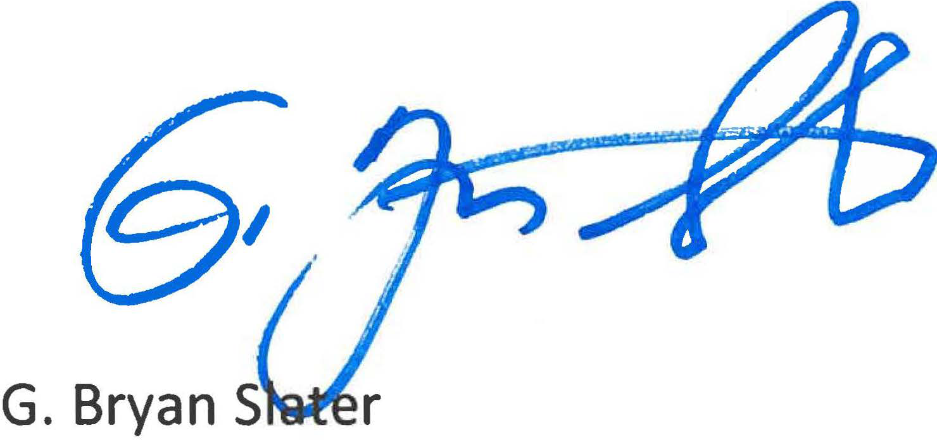

As for the alleged regulatory violations in your case, I note that former Director Thota's May 9, 2024, letter and attachment provided detailed information not only for the three allegations you set forth in your original complaint, but also on the actions DPOR's staff took to determine if your complaint presented indications of other possible statutory violations or to address new allegations you raised in your April 9, 2024 email. It appears that DPOR's staff took the initiative to identify issues for investigation that did not appear in your original complaint.

In sum, our second review of DPOR's actions in your case indicate that DPOR conducted a thorough investigation of your complaint. Mr. Thota provided detailed summaries for each of the 14 prior and new allegations set out in your correspondence of April 9, 2024. It is clear you disagree with DPOR's view of the evidence. produced during the investigation of your complaint, which is your right. In our review of this matter, however, we have determined that DPOR's investigation was proper and objective, and that the outcomes were appropriate based on the evidence before the DPOR staff and ultimately, the Board for Contractors. Thank you for bringing your concerns to our attention.

Sincerely,

cc: Brian Wolford, Director, DPOR